**MANAV SHARMA**

**G L Bajaj Institute Of Technology And Management | UP**

 [**manav955 6@g ma il.c o m**](mailto:manav9556@gmail.com) ** (+91) 8810310850**

 **Linkedin**  **Github**  **Faridabad,Haryana**

**EXPERIENCE**

* Software Engineer Odessa Sep 2021 - Feb 2023 (1 year 6 months)
* Rewrote legacy code for a key customer-facing feature, increasing reliability by 30%.
* Deveolpe various core modules with help of odessa framework and C# odessa framework is based on .net and used linq to attach it with the database .
* Reduced SQL procedures runtime by 75% through optimisations, reducing the workload on the server.

Also worked as Devops Person for team to ensure the release on proper time and maintains the to ensure no down time . Automated severeal action on pipline using powershell scripting and created piplene in azure

**PROJECTS**

**To do list**

**Self-Learnin g** **Project**

This app is used to track and maintain your daily tasks .UI of this web page is developed with the help of Reactjs HTML,CSS and in this we can add the new element also store the data in local storage of web page .

• **Tech-Stack** **> HTML,CSS,React,LocalS torageof browser to store data**

*  [Github](https://github.com/manav9556/) Repository.



COVID-19 Tracker

**Self-Learning** **Project**

Covid-19 Tracker which could provide real-time analysis of the covid daily cases, recovered ones and the number of deaths incurred in the country because of covid-19

Tech-Stack>.JavaScript, React Js,HTML and CSS and using react routing

•  [Github](https://github.com/manav9556/) Repository.



**EDUCATION**

Bachelor of Technology(CSE)

**GL Bajaj Institute of Technology and Management**

2022



Class XII

**Aggarwal Public School**



2018

**SKILLS**

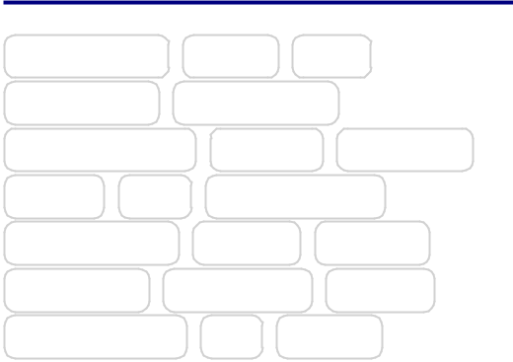

|  |  |  |
| --- | --- | --- |
| C/C++ | OOPs | DSA |
| C# | .NET |  |
| SQLServer | MySQLREST API | |
| HTMLCSS BOOTSTRAP | | |
| JAVASCRIP T | Nodejs | Express |
| MongoDB | LINQ | REACT |
| Redux Toolkit | Git | Github |

**ACHIEVEMENT**

* **350** DSA coding questions Solved

•

* HackerRank(manav9556)
* 5 stars(★★★★★) in Problem Solv

4 Stars (★★★★)in c++

* Geeksf orgeeks[(manav9556)](https://auth.geeksforgeeks.org/user/manav9556/practice/) 679 score in progress
* LeetCode([manav9556)](https://leetcode.com/manav9556/))
* CodeChef([manv9556](https://www.codechef.com/users/manav9556)) 3 stars

score(1625)

Ecommerce Dashboard

**Self-Learnin g** **Project**

* Developed an e-commerce dashboard using React with features including user authentication, product management, and CRUD operations (Create, Read, Update, Delete).
* **Tech-Stack > React,Node,E xpress,MongoDB,CSS,vscode**
*  [Github Repository.](https://github.com/manav9556/)

**SOFT SKILLS**



Teamwork Problem Solving Creativity Adaptability